[Health Canada Drug Product Database (DPD) in MySQL](http://www.leadlab.ca/2013/02/22/health-canada-dpd-mysql/" \o "Health Canada Drug Product Database (DPD) in MySQL)

Feb222013

The most recent LeadLab development effort is enhancing OSCAR to support the new BC Interoperability Specification for Primary Care (See [PITO EMR-TO-EMR DATA TRANSFER & CONVERSION (E2E-DTC) SPECIFICATIONS](http://www.pito.bc.ca/about-emrs/interoperability/specifications/)).

The E2E-DTC is a CDA-based spec. Some new lab members are now getting their feet with HL7, the RIM, and all these wonderful things.

More recently the focus has been on mapping medications from OSCAR to the E2E spec. There is some very detailed analysis happening on medication codes, form codes, route codes, etc. However, because OSCAR relies heavily on the DPD this mapping work is almost like mapping purely from the D2D to E2E.

To help me I quickly created a MySQL table structure so I could query the DPD export tables in a relational fashion. The SQL script to create this database can be downloaded[here](http://www.leadlab.ca/2013/02/22/health-canada-dpd-mysql/hc_dpd_tables_mysql-sql/).

[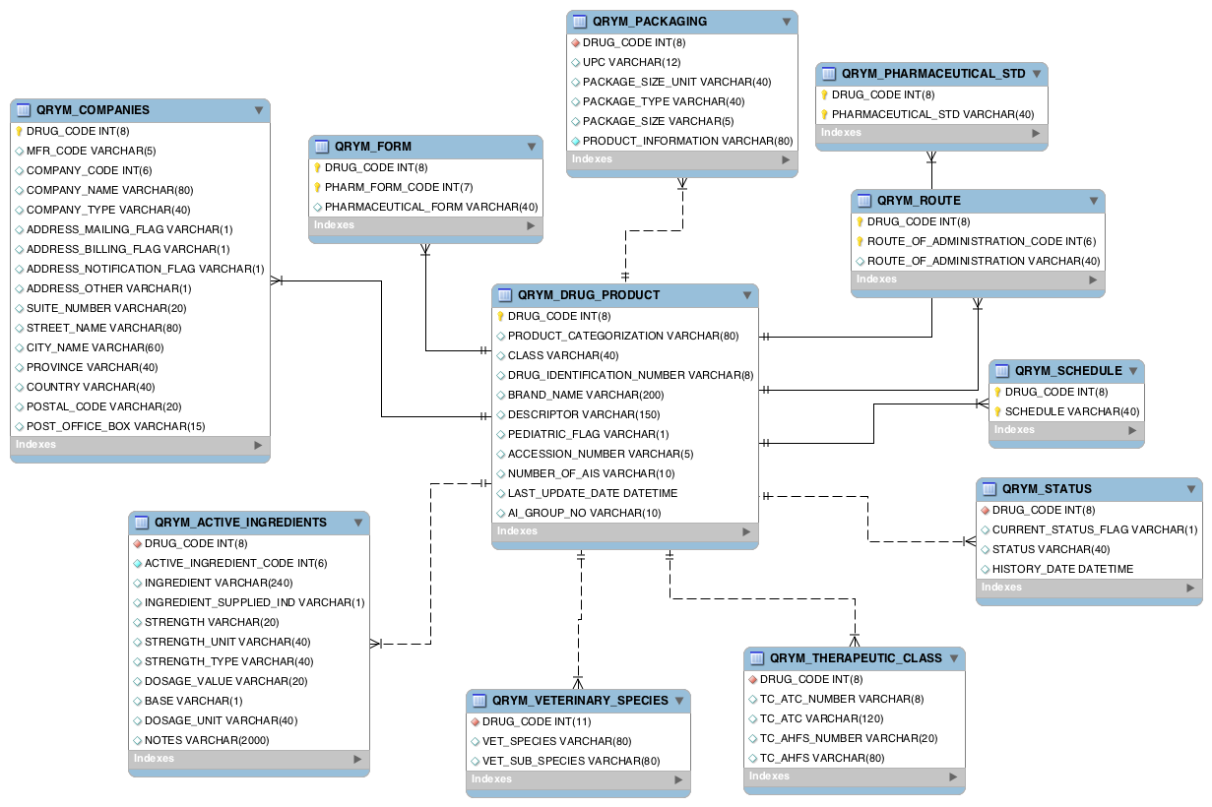](http://www.leadlab.ca/2013/02/22/health-canada-dpd-mysql/hc_dpd_mysql/)

After you have created the empty database in MySQL, you will need to download the HC DPD extract files [here](http://www.hc-sc.gc.ca/dhp-mps/prodpharma/databasdon/dpd_bdpp_data_extract-eng.php). Simply download the “All Files” option.

Next you can load the extract files into MySQL using the following statements (Note: there is an assumption here that since you want to navigate the DPD in MySQL that you actually know enough about MySQL to run these commands from the right location).

LOAD DATA INFILE 'drug.txt' INTO TABLE QRYM_DRUG_PRODUCT FIELDS TERMINATED BY ',' OPTIONALLY ENCLOSED BY '"' LINES TERMINATED BY '\r\n' (DRUG_CODE, PRODUCT_CATEGORIZATION, CLASS, DRUG_IDENTIFICATION_NUMBER, BRAND_NAME, DESCRIPTOR, PEDIATRIC_FLAG, ACCESSION_NUMBER, NUMBER_OF_AIS, @date, AI_GROUP_NO) SET LAST_UPDATE_DATE = str_to_date(@date, '%d-%b-%Y');

LOAD DATA INFILE 'comp.txt' INTO TABLE QRYM_COMPANIES FIELDS TERMINATED BY ',' OPTIONALLY ENCLOSED BY '"' LINES TERMINATED BY '\r\n' (DRUG_CODE, MFR_CODE, COMPANY_CODE, COMPANY_NAME, COMPANY_TYPE,ADDRESS_MAILING_FLAG, ADDRESS_BILLING_FLAG, ADDRESS_NOTIFICATION_FLAG,ADDRESS_OTHER, SUITE_NUMBER, STREET_NAME, CITY_NAME, PROVINCE, COUNTRY,POSTAL_CODE, POST_OFFICE_BOX);

LOAD DATA INFILE 'form.txt' INTO TABLE QRYM_FORM FIELDS TERMINATED BY ',' OPTIONALLY ENCLOSED BY '"' LINES TERMINATED BY '\r\n' (DRUG_CODE,PHARM_FORM_CODE, PHARMACEUTICAL_FORM);

LOAD DATA INFILE 'ingred.txt' INTO TABLE QRYM_ACTIVE_INGREDIENTS FIELDS TERMINATED BY ',' OPTIONALLY ENCLOSED BY '"' LINES TERMINATED BY '\r\n' (DRUG_CODE, ACTIVE_INGREDIENT_CODE, INGREDIENT,INGREDIENT_SUPPLIED_IND, STRENGTH, STRENGTH_UNIT, STRENGTH_TYPE,DOSAGE_VALUE, BASE, DOSAGE_UNIT, NOTES);

LOAD DATA INFILE 'package.txt' INTO TABLE QRYM_PACKAGING FIELDS TERMINATED BY ',' OPTIONALLY ENCLOSED BY '"' LINES TERMINATED BY '\r\n' (DRUG_CODE, UPC, PACKAGE_SIZE_UNIT, PACKAGE_TYPE, PACKAGE_SIZE,PRODUCT_INFORMATION);

LOAD DATA INFILE 'pharm.txt' INTO TABLE QRYM_PHARMACEUTICAL_STD FIELDS TERMINATED BY ',' OPTIONALLY ENCLOSED BY '"' LINES TERMINATED BY '\r\n' (DRUG_CODE, PHARMACEUTICAL_STD);

LOAD DATA INFILE 'route.txt' INTO TABLE QRYM_ROUTE FIELDS TERMINATED BY ',' OPTIONALLY ENCLOSED BY '"' LINES TERMINATED BY '\r\n' (DRUG_CODE,ROUTE_OF_ADMINISTRATION_CODE, ROUTE_OF_ADMINISTRATION);

LOAD DATA INFILE 'schedule.txt' INTO TABLE QRYM_SCHEDULE FIELDS TERMINATED BY ',' OPTIONALLY ENCLOSED BY '"' LINES TERMINATED BY '\r\n' (DRUG_CODE, SCHEDULE);

LOAD DATA INFILE 'status.txt' INTO TABLE QRYM_STATUS FIELDS TERMINATED BY ',' OPTIONALLY ENCLOSED BY '"' LINES TERMINATED BY '\r\n' (DRUG_CODE, CURRENT_STATUS_FLAG, STATUS, @date) SET HISTORY_DATE = str_to_date(@date, '%d-%b-%Y');

LOAD DATA INFILE 'ther.txt' INTO TABLE QRYM_THERAPEUTIC_CLASS FIELDS TERMINATED BY ',' OPTIONALLY ENCLOSED BY '"' LINES TERMINATED BY '\r\n' (DRUG_CODE, TC_ATC_NUMBER, TC_ATC, TC_AHFS_NUMBER, TC_AHFS);

LOAD DATA INFILE 'vet.txt' INTO TABLE QRYM_VETERINARY_SPECIES FIELDS TERMINATED BY ',' OPTIONALLY ENCLOSED BY '"' LINES TERMINATED BY '\r\n' (DRUG_CODE, VET_SPECIES, VET_SUB_SPECIES);